AUTOMATED UNDERWRITING USER STORY
- Description
As an underwriting system
I want to evaluate insurance proposals using predefined underwriting rules
So that low-risk cases can be automatically approved, medium-risk cases can be reviewed by underwriters, and high-risk cases can be rejected or flagged for investigation.

- Acceptance Criteria
ID | Description
AC1 | System should evaluate proposal data after the proposal is submitted.
AC2 | System should apply predefined underwriting rules based on age, health declarations, lifestyle information, and income eligibility.
AC3 | If the proposal meets all low-risk criteria, the system should automatically approve the proposal through Straight Through Processing (STP).
AC4 | If the proposal falls under medium-risk criteria, the system should route the proposal to a manual underwriter for further review.
AC5 | If the proposal matches high-risk criteria, the system should automatically reject the proposal or flag it for investigation.
AC6 | The underwriting decision (Approved, Referred, Rejected) should be stored in the system.
AC7 | The system should notify the relevant stakeholders about the underwriting decision.
AC8 | The system should maintain an audit trail of the underwriting decision and rules applied.

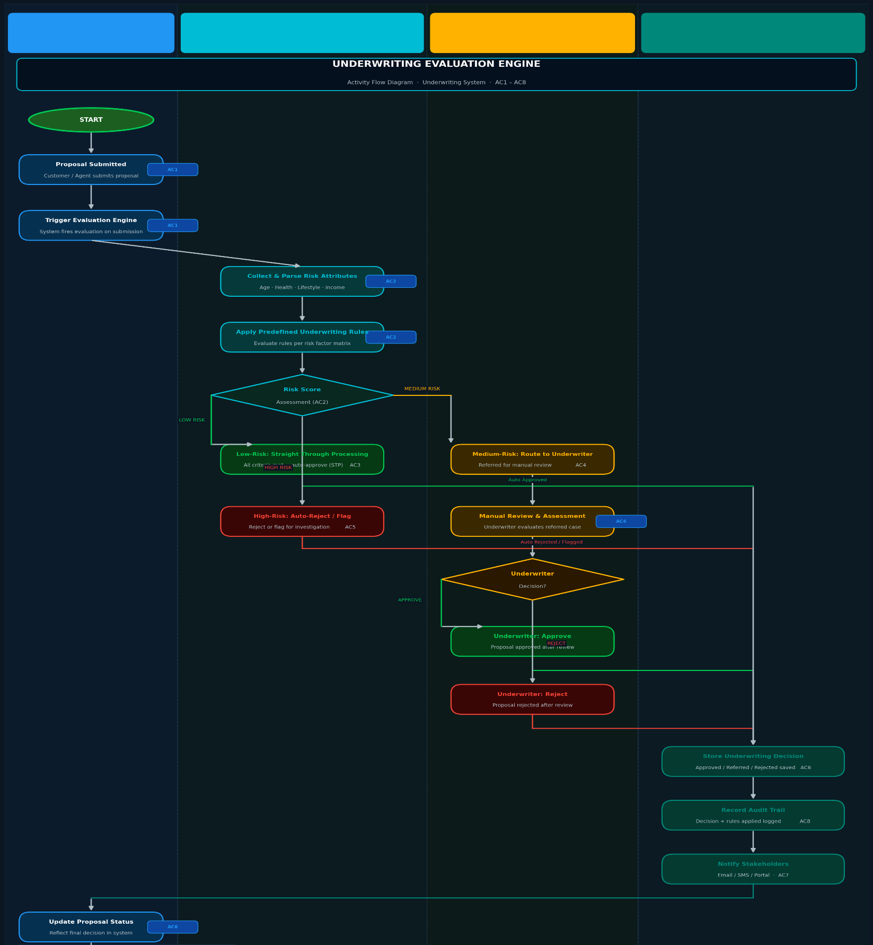
- Activity Flow Diagram

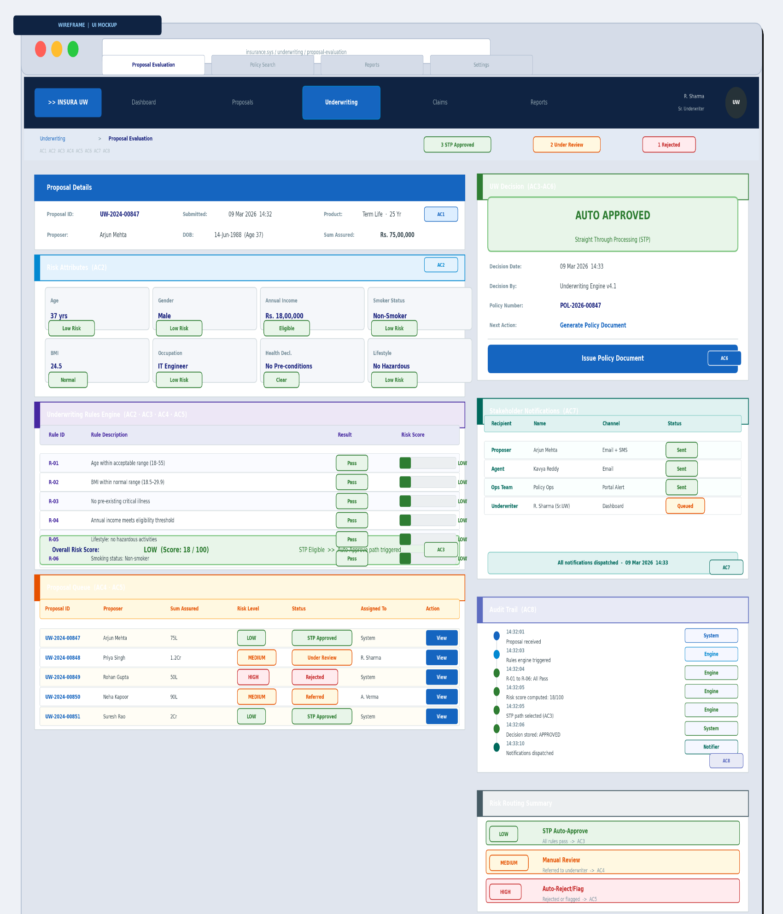
- Wireframe

